- Web Api using .Net core with Swagger

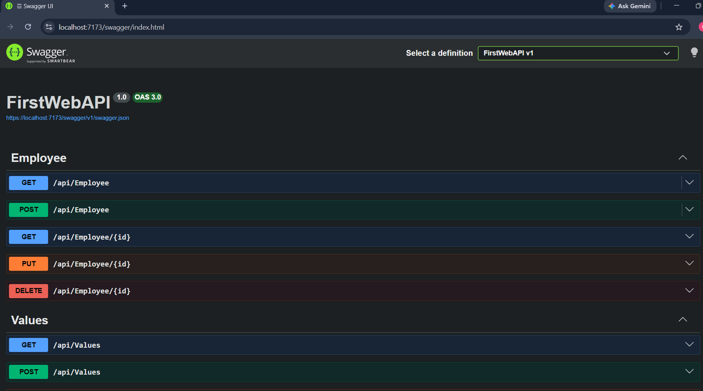
Swagger page showing the Employee controller

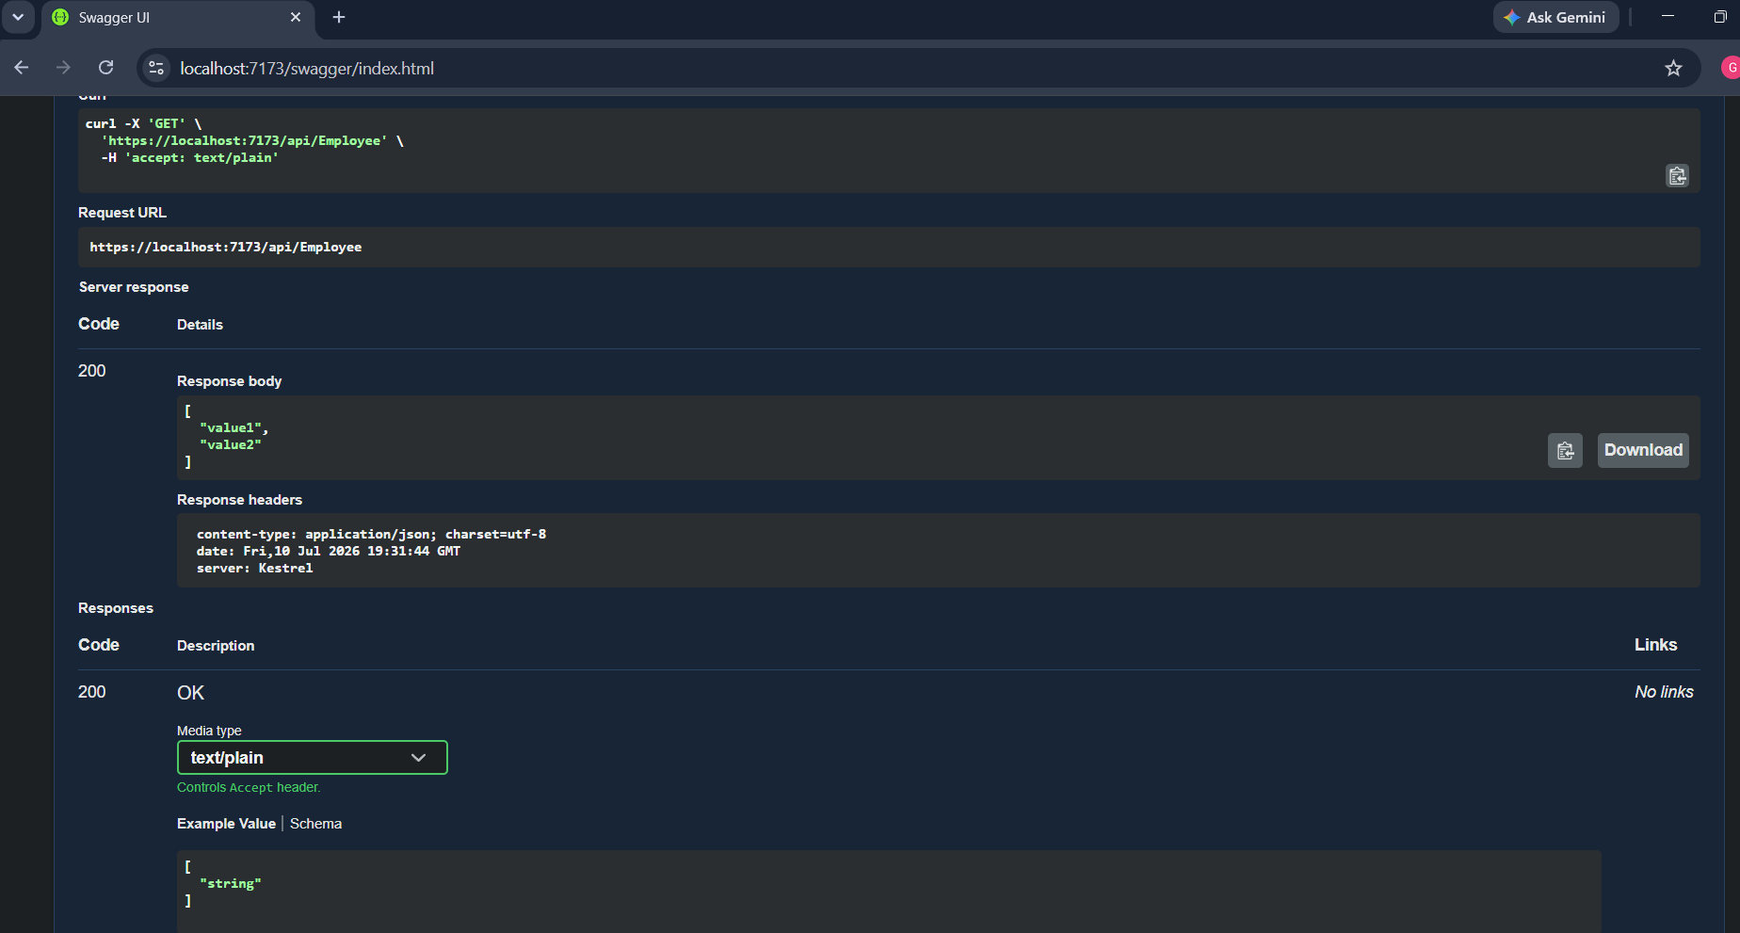
Swagger GET /api/Employee executed showing 200 OK.

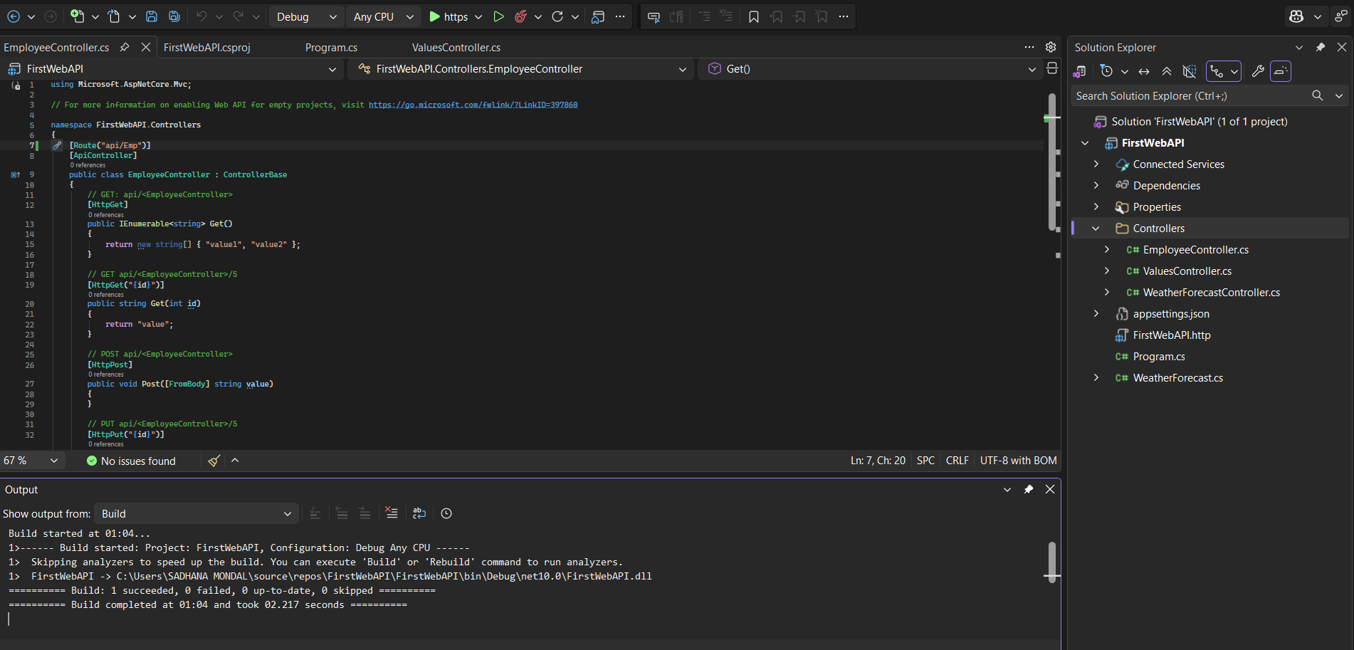
EmployeeController.cs showing the route changed to:
[Route("api/Emp")]

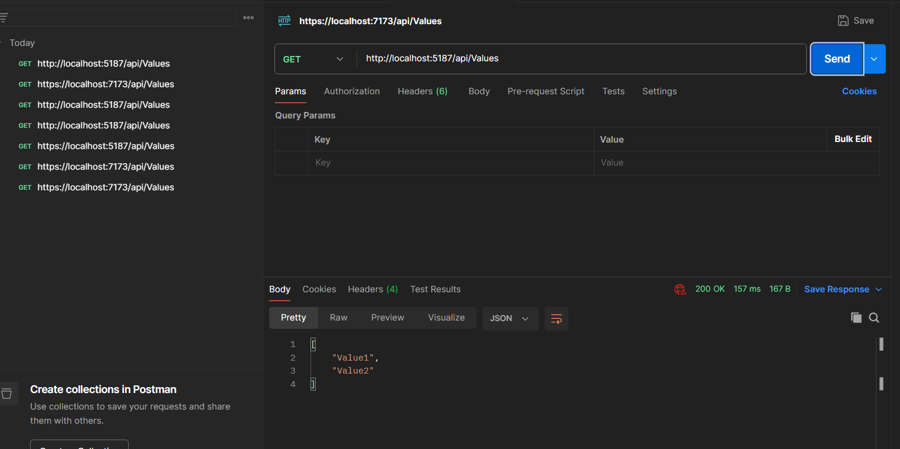
Postman GET /api/Emp showing 200 OK.

